A000-PAC-Melanesia-Fiji-Ula-Throwing Club-Iron Wood-19th C

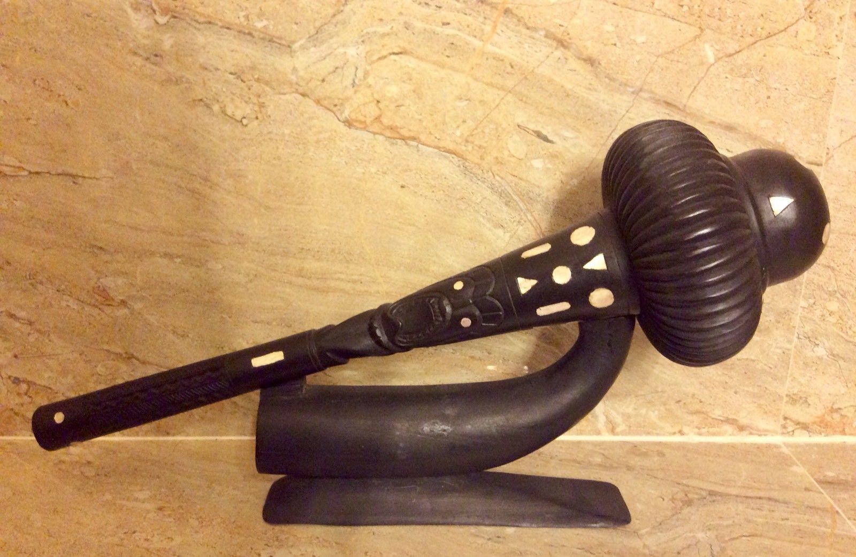

Fig. 1. The Throwing Club measures: 19 inches long by 6 inches wide at the club head. The stand measures: 5 1/2 inches tall by 10 inches wide by 2 inches deep.

**Case no.: 13**

**Accession Number:**

**Formal Label:** Melanesia-Fiji-Sali-Ceremonial Throwing Club-Lighter Iron Wood-20th C

**Display Description:**

Sali Fijian War Club, also known as Cali or Tebetebe, these clubs are similar to Gata clubs but they have wider cheeks and a more pronounced spur. They were used in the same way as a Gata with a cutting edge to snap and cut bone. A fine example of the throwing club with a stand from Fiji, the *ula*. The name “*ula”* comes from the buttress root of the iron wood tree. This club was designed to be thrown from a distance causing injury to incapacitate the victim, and then the killer blow was delivered at close range. The handle is decorated with deep geometric carvings to note the number of victims killed by it which adds to its *mana* or spiritual power. Also carved are Tiki designs, which indicate the spirit inhering in the club. Also inlaid mother of pearl pieces signify victim’s teeth. There is a variety of Sali made from a lighter wood made for ceremonial dances. Sometimes these clubs are ahistorically described as a gunstock clubs, since guns were unknown to the Fijians when they first made these clubs.

**LC Classification:** GN497

**Date or Time Horizon:** mid 20th c

**Geographical Area:** Fiji

**LC Classification:** GN497

**Date or Time Horizon:** mid 20th c

**Geographical Area:** Fiji

**Maps:**

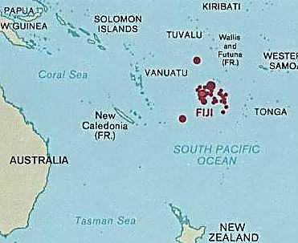

Fig. 2. Location of Fiji archipelago in the western Pacific. After <https://upload.wikimedia.org/wikipedia/commons/a/a8/Fiji_and_oceania.jpg>

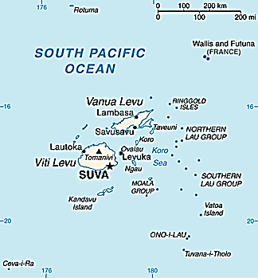

Fig. 3. Fiji archipelago. After https://upload.wikimedia.org/wikipedia/commons/e/e1/Fiji_map.png

**GPS coordinates: Suva:** [18°10′S 178°27′E](https://tools.wmflabs.org/geohack/geohack.php?pagename=Fiji&params=18_10_S_178_27_E_type:city)

**Cultural Affiliation:** Melanesian

**Medium:** Iron wood. Mother of pearl.

**Dimensions:**

**Weight:**

**Condition: original**

**Provenance:** Acquired from Master Daniel D. Moreland of the Pitcairn Island barque, Picton Castle, when it anchored at Marblehead, Massachusetts, in July, 2005. 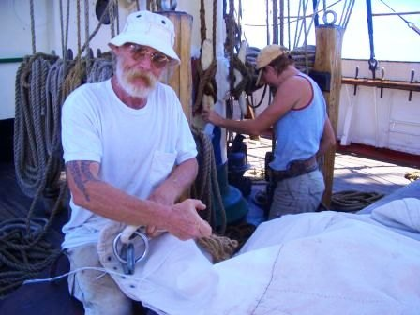 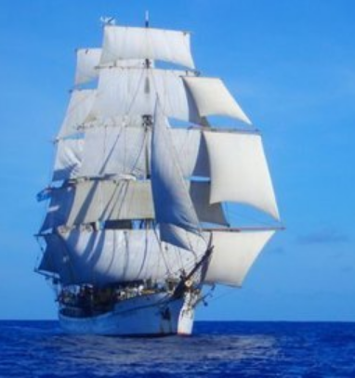

Fig. 4. Master Daniel D. Moreland stitching sails on the course to Bali. After http://www.picton-castle.com/archive/captains_logs/captains-log-pics/2005_11/log66/Morgan_stitching_and_Rebecca_painting_on_the_way_to_Bali.jpg

Fig. 5. The Pitcairn barque, *Picton Castle*, under stun sails. After http://www.picton-castle.com/archive/captains_logs/captains-log-pics/2005_11/log63/Picton_Castle_under_stuns'ls,__on_the_way_to_Bali.jpg

**Discussion:**

Fiji was first settled ca 3500 BCE by Polynesian Lapita peoples.  Lapita culture was both inventive and syncretistic. It created a distinctive dentate stamped ceramic type. Being great mariners of outrigger canoes, the Lapita people were always looking beyond the horizon. The Lapita people assimilated many contributions, including those from southern China (agriculture), Island South-East Asia (domesticated animals, pottery and Austronesian languages) and the material riches of the empty islands beyond the Bismarcks and the Solomons -- Vanuatu, New Caledonia, Fiji and Polynesia (Kirch 1997; Jones and Spriggs 2002).

The trail of Early Lapita sites allows us to follow their continuing migrations. About **1150 BCE** the people of the Feni archipelago traded Lapita pottery to those who ventured to clayless Nissan atoll (Lebang Halika and Yomining) (Wickler 1990, 2003). About **1000 BCE** Lapita settlers built stilt houses on sandy reef flats at Kessa in northern Buka Island. About **950 BCE** the Buka Island Lapita sites traded pottery to those living at the Tarmon reef settlement en route to Nissan Island’s central lagoon. About **900 BCE** a Lapita settlement was established at Sohano Island off south Buka Island (Wickler 1990, 2003). Finally, Lapita people colonized the Fijian archipelago, ca 800 BCE. Sunseqently warlike Melanesians migrated to the islands forced many of the Polynesians to migrate to Samoa and Tonga. However, Fijian culture remained a mixture of Melanesians and Polynesians. In fact, canoes made from native Fijian trees have been found in Tonga and Tongan and loan words are part of the language of the Lau group of islands. Fijian ceramics of the Melanesian variety have been found in Samoa and as far away as the Marquesas Islands.

Melanesian Fijians encountered the expeditions of Captain James Cook who met them in Tonga and he described them as formidable warriors and ferocious cannibals, builders of fine vessels. All of their manufactures, especially bark cloth and clubs like this one, were highly valued and much in demand. They called their home Viti, but the Tongans called it Fisi.

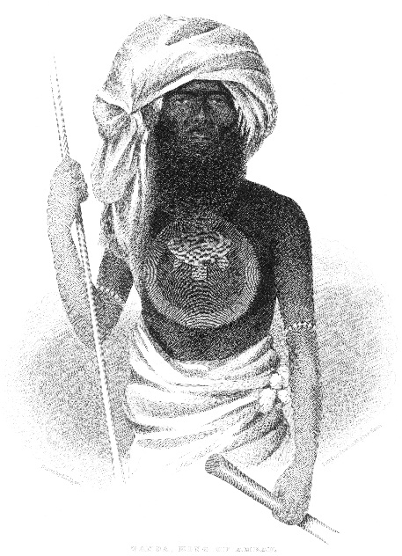 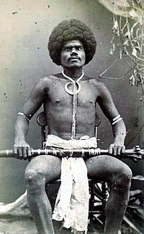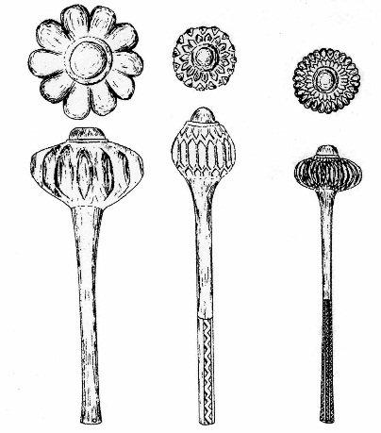

**Tanoa, Melanesian King of Ambau Island, holding a war club and spear, drawn by A. T. Agate, ca 1885. After** [**https://upload.wikimedia.org/wikipedia/commons/a/ab/Ratu_Tanoa_Visawaqa.jpg**](https://upload.wikimedia.org/wikipedia/commons/a/ab/Ratu_Tanoa_Visawaqa.jpg)

Fijian mountain warrior, Kai Colo. Carte de visite photograph, 1870's. The subject holds a rootstock club and wears a boar's tusk necklace.

After photographer: F.H. Dufty, Levuka, Fiji, 1870’s- <http://www.oceania-ethnographica.com/poly127.html>

Ula Tavatava Ula with flanges or lobes on the head of the club http://www.new-guinea-tribal-art.com/wp/wp-content/uploads/2011/09/Ula-Tavatava-263x300.jpg

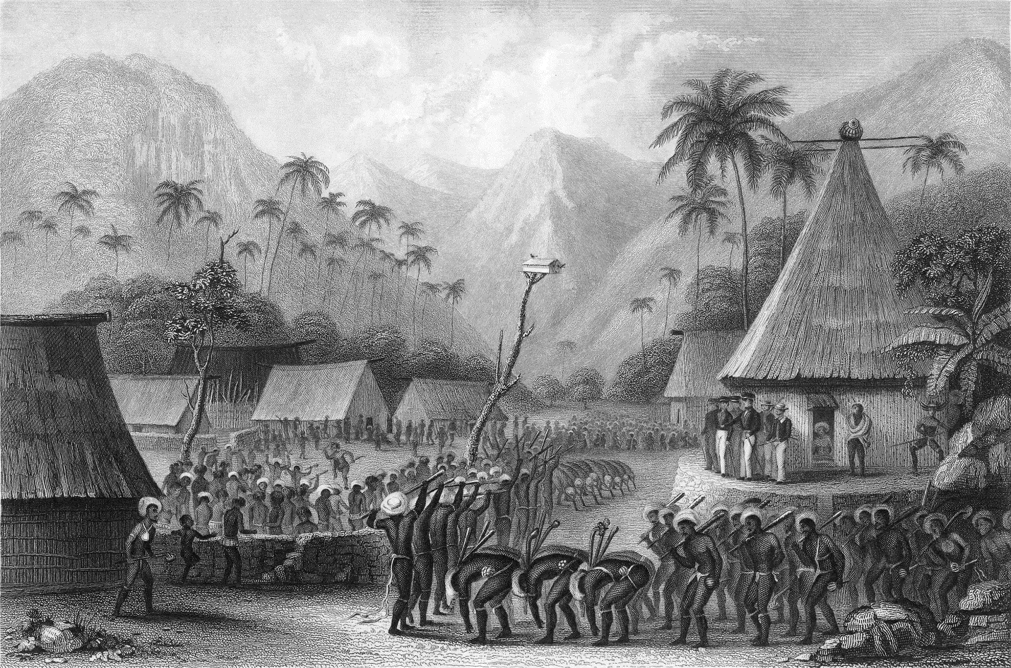

Fig. 8. Scene depicting American sailors being fêted with a war dance.Drawn by Joseph Drayton. Engraved by Rawdon, Wright & Hatch. From Erskine 1896. between pp. 144-145.

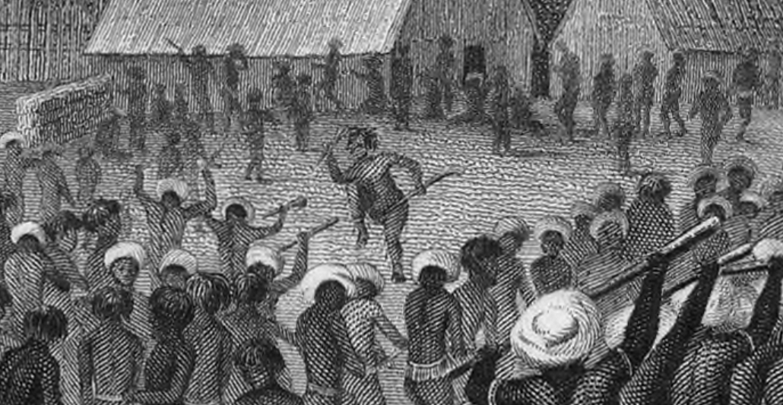

Fig. 9. Detail of a scene depicting American sailors being fêted with a war dance.Drawn by Joseph Drayton. Engraved by Rawdon, Wright & Hatch. From Erskine 1896. between pp. 144-145.

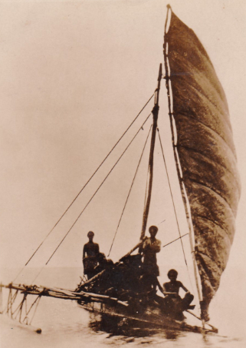

Fijian outrigger canoe, published by James Muir, Suva, N. 18. Ca 1910.

This war dance involves a single dancer who holds two war clubs, one, a Sali, to kill the enemy by throwing, and the other war club used for snapping bone and cutting human flesh, being performed before an entourage of American sailors who hold their guns ready, knowing that they were out-manned.

The number and variety of Fijian war clubs is testament to the fact that Fiji was beset by a long history of warfare and rampant ceremonial cannibalism. Fijian clubs were the most cherished personal possessions of the Fijian warrior. Fijian clubs that had been successfully use to kill were either inlayed with human teeth or by the cutting of notches on the grip. A club use to kill many enemies was believed to have a life power of its own or *mana*. Fijian War clubs with large amounts of *mana* were sometimes placed in a temple to the gods of war, and they became ritual objects in funerary rites and certain craft ceremonies.

References:

Clunie, Fergus. 1977. *Fijian weapons and warfare*. Fiji Museum.

Erskine, Charles. 1896. *Twenty years before the mast*. Philadelphia: George W. Jacobs & Co.

**Discussion:**

Ca 3000 BP Polynesian colonizers left the Bismarck Archipelago, moved down the Solomon Island chain and populated Vanuatu, New Caledonia, Fiji, Tonga and Samoa. These colonizers made a distinctive type of pottery called Lapita, for a site in New Caledonia and now used for the Lapita Cultural Complex. When they colonized Fiji, Tonga and Samoa, they developed in isolation. Fiji was first settled ca 2500 BCE. Subsequent migration of Melanesians into the Fijian archipelago ca 2000 BCE forced many Polynesians to migrate to Samoa and Tonga. However, some Polynesians remained and created a hybrid Melanesian-Polynesian culture. Trade between Fiji and neighboring archipelagos is testified by outrigger canoes made from native Fijian trees found in Tonga and Tongan words formed part of the language of the Lau group of islands. Fijian ceramics have been found in Samoa and as far away as the Marquesas Islands.

When Captain James Cook encountered Fijians in Tonga he described them as formidable warriors and ferocious cannibals, builders of fine outriggers but not great sailors. All of their manufactures, especially bark cloth and clubs like this one, were highly valued and much in demand. They called their home Viti, but the Tongans called it Fisi. The number and variety of Fijian war clubs is testament to the fact that Fiji was beset by a long history of warfare and rampant ceremonial cannibalism. This article aims to help the reader understand and distinguish the different types and their intended specialized functions. Fijian clubs were the most cherished personal possessions of the Fijian warrior. It was designed and made for specific purposes and there are approximately thirty distinct and diverse types of Fijian War club. Fijian clubs that had been successfully use to kill were either inlayed with human teeth or by the cutting of notches on the grip. A club use to kill many enemies was believed to have a life power of its own or mana. A Fijian War club with large amounts of mana were sometimes placed in a temple to the gods of war, and became ritual objects in funerary rites and certain craft ceremonies.

References:

Beaglehole, J. C. ed. 1961. *The Voyage of the Resolution and Adventure*. Cambridge, England: Cambridge University Press.

Beaglehole, J. C. ed. 1955. *The Journals of Captain James Cook*. Cambridge, England: Cambridge University Press.

Beaglehole, J. C. 1934. *The Exploration of the Pacific.* London: A. C. Black.

Clunie, Fergus. 1977. *Fijian weapons and warfare*. Suva: Fiji Museum.

Erskine, Charles. 1896. *Twenty years before the mast.* Philadelphia: George W. Jacobs & Co.